Карта границ населенного пункта
х.Кононов Литвиновского сельского поселения

Условные обозначения:
- планируемая граница населенного пункта
- номера основных поворотных точек планируемой границы населенного пункта

Условные обозначения:
- планируемая граница населенного пункта
- номера основных поворотных точек планируемой границы населенного пункта

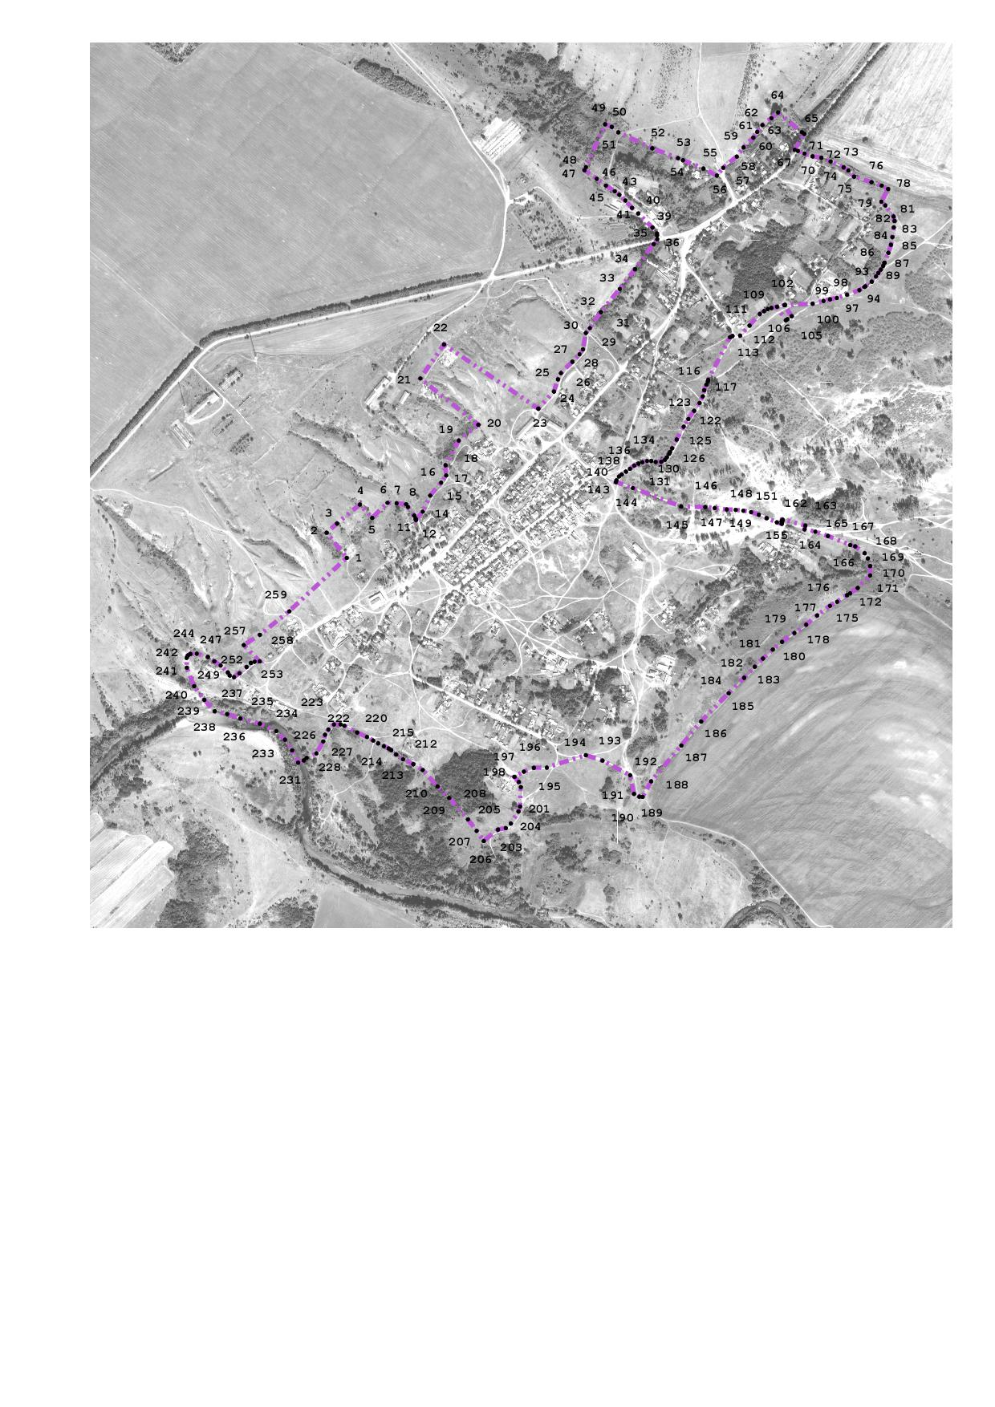

Каталог координат
поворотных точек границы х. Кононов
Литвиновского сельского поселения

 | X(м) | Y(м)
1 | 554082,43 | 2295969,59
2 | 554153,98 | 2295911,99
3 | 554180,31 | 2295941,75
4 | 554234,56 | 2296006,85
5 | 554196,17 | 2296041,95
6 | 554239,53 | 2296085,65
7 | 554238,32 | 2296111,59
8 | 554235,54 | 2296138,81
9 | 554227,7 | 2296143,82
10 | 554202,95 | 2296161,85
11 | 554194,7 | 2296165,62
12 | 554190,91 | 2296167
13 | 554190,96 | 2296167,08
14 | 554214,35 | 2296186,12
15 | 554260,17 | 2296207,69
16 | 554297,23 | 2296238,68
17 | 554317,69 | 2296253,08
18 | 554346,77 | 2296251,31
19 | 554417,14 | 2296289,09
20 | 554462,42 | 2296344,72
21 | 554594,45 | 2296179,63
22 | 554691,37 | 2296246,91
23 | 554508,32 | 2296516,27
24 | 554557,21 | 2296560,9
25 | 554591,84 | 2296571,89
26 | 554609,58 | 2296580,43
27 | 554642,15 | 2296613,22
28 | 554663,65 | 2296633,64
29 | 554677,59 | 2296643,71
30 | 554724,24 | 2296651,81
31 | 554738,16 | 2296663,07
32 | 554783,73 | 2296694,76
33 | 554849,8 | 2296748,59
34 | 554906,35 | 2296791,83
35 | 554978,12 | 2296845,3
36 | 554991,84 | 2296855,51
37 | 555002,94 | 2296854,89
38 | 555008,04 | 2296854,61
39 | 555025,44 | 2296841,71
40 | 555065,33 | 2296801,1
41 | 555081,54 | 2296783,51
42 | 555102,24 | 2296764,61
43 | 555118,74 | 2296747,21
44 | 555128,94 | 2296734,31
45 | 555145,1 | 2296709,09
46 | 555164,25 | 2296682,9
47 | 555188,84 | 2296647,9
48 | 555197,7 | 2296651,96
49 | 555320,04 | 2296706,71
50 | 555312,54 | 2296725,61
51 | 555296,94 | 2296744,51
52 | 555251,17 | 2296841,12
53 | 555223,2 | 2296914,9
54 | 555217,4 | 2296928,62
55 | 555193,44 | 2296987,21
56 | 555173,7 | 2297025,49
57 | 555195,75 | 2297043,78
58 | 555227,8 | 2297082,44
59 | 555254 | 2297101,57
60 | 555281,85 | 2297129,42
61 | 555298,1 | 2297140,65
62 | 555317,6 | 2297155,65
63 | 555337,48 | 2297181,28
64 | 555353,9 | 2297200,38
65 | 555297,4 | 2297268,29
66 | 555292,44 | 2297275,21
67 | 555247,44 | 2297247,61
68 | 555243,78 | 2297256,99
69 | 555236,64 | 2297275,51
70 | 555228,54 | 2297298,61
71 | 555224,34 | 2297323,81
72 | 555213,84 | 2297350,21
73 | 555197,04 | 2297387,11
74 | 555188,04 | 2297400,91
75 | 555170,64 | 2297417,11
76 | 555154,74 | 2297466,61
77 | 555145,14 | 2297496,01
78 | 555135,24 | 2297514,31
79 | 555099,13 | 2297494,9
80 | 555088,15 | 2297506,41
81 | 555056,5 | 2297529,95
82 | 555044,04 | 2297532,41
83 | 555025,95 | 2297530,37
84 | 554997,9 | 2297526,37
85 | 554975,94 | 2297522,11
86 | 554953,14 | 2297514,91
87 | 554925,25 | 2297503,83
88 | 554924,02 | 2297503,3
89 | 554915,95 | 2297499,82
90 | 554904,95 | 2297493,31
91 | 554895,5 | 2297486,06
92 | 554885,5 | 2297479,55
93 | 554870,7 | 2297467,52
94 | 554857,24 | 2297449,21
95 | 554855,5 | 2297446,42
96 | 554846,65 | 2297432,21
97 | 554833,24 | 2297396,81
98 | 554824,1 | 2297368,09
99 | 554820,04 | 2297348,21
100 | 554815,74 | 2297329,81
101 | 554807,5 | 2297298,47
102 | 554804,13 | 2297220,24
103 | 554803,7 | 2297218,27
104 | 554772,12 | 2297238,93
105 | 554763,65 | 2297227,18
106 | 554760,5 | 2297222,63
107 | 554799,14 | 2297197,34
108 | 554795,62 | 2297181,14
109 | 554792,38 | 2297170,91
110 | 554786,45 | 2297160,13
111 | 554778,54 | 2297148,27
112 | 554745,3 | 2297118,8
113 | 554716,62 | 2297091,86
114 | 554715,72 | 2297070,07
115 | 554711,9 | 2297063,33
116 | 554590,5 | 2297000,97
117 | 554586,35 | 2296999,47
118 | 554576,85 | 2296995,71
119 | 554561,05 | 2296989,45
120 | 554543,3 | 2296985,19
121 | 554524,55 | 2296976,21
122 | 554502,25 | 2296960,94
123 | 554478,7 | 2296944,4
124 | 554457 | 2296930,9
125 | 554420,15 | 2296910,86
126 | 554395,1 | 2296898,08
127 | 554384,68 | 2296892,26
128 | 554379,2 | 2296889,21
129 | 554369,45 | 2296882,94
130 | 554362,15 | 2296877,43
131 | 554356,65 | 2296866,91
132 | 554356,15 | 2296850,87
133 | 554359,15 | 2296838,34
134 | 554359,15 | 2296826,56
135 | 554355,4 | 2296812,79
136 | 554351,4 | 2296801,77
137 | 554345,6 | 2296789,49
138 | 554336,6 | 2296777,46
139 | 554328,35 | 2296766,19
140 | 554320,55 | 2296753,92
141 | 554314,55 | 2296745,9
142 | 554304,05 | 2296739,14
143 | 554298,8 | 2296737,8
144 | 554281,44 | 2296785,91
145 | 554228,94 | 2296923,61
146 | 554227,44 | 2296992,31
147 | 554224,2 | 2297018,96
148 | 554220,54 | 2297053,81
149 | 554219,25 | 2297079,24
150 | 554217,15 | 2297101,27
151 | 554213,04 | 2297123,11
152 | 554205,54 | 2297145,31
153 | 554195,64 | 2297167,81
154 | 554183,85 | 2297196,69
155 | 554179,5 | 2297210,52
156 | 554180,63 | 2297210,95
157 | 554185,53 | 2297211,52
158 | 554185,91 | 2297210,28
159 | 554190,02 | 2297211,55
160 | 554189,55 | 2297213,08
161 | 554191,08 | 2297213,55
162 | 554174,41 | 2297277,88
163 | 554163,88 | 2297275,91
164 | 554157,25 | 2297306,45
165 | 554144,64 | 2297342,41
166 | 554118,84 | 2297406,01
167 | 554115,24 | 2297420,41
168 | 554095,44 | 2297447,41
169 | 554080,78 | 2297456,3
170 | 554058,99 | 2297463,04
171 | 554032,26 | 2297463,04
172 | 553996,33 | 2297427,55
173 | 553981,02 | 2297405,72
174 | 553975,95 | 2297396,84
175 | 553956,9 | 2297368,65
176 | 553945,35 | 2297348,1
177 | 553918,1 | 2297311,95
178 | 553891,55 | 2297280,51
179 | 553868 | 2297246,73
180 | 553842,7 | 2297211,77
181 | 553820,65 | 2297185,22
182 | 553795,05 | 2297156,96
183 | 553771,44 | 2297133,64
184 | 553740,1 | 2297103,45
185 | 553696 | 2297059,37
186 | 553615,3 | 2296980,71
187 | 553546,8 | 2296924,21
188 | 553444,55 | 2296838,04
189 | 553400,2 | 2296813,48
190 | 553400,7 | 2296804,71
191 | 553408,45 | 2296789,19
192 | 553462,16 | 2296777,94
193 | 553503,46 | 2296699,45
194 | 553518,9 | 2296651,44
195 | 553483,51 | 2296540,33
196 | 553483,06 | 2296503,49
197 | 553472,15 | 2296474,6
198 | 553457,33 | 2296448,09
199 | 553442,73 | 2296460,45
200 | 553428,13 | 2296466,06
201 | 553372,87 | 2296464
202 | 553358,37 | 2296459,5
203 | 553323,88 | 2296437,57
204 | 553311,02 | 2296423,14
205 | 553306,98 | 2296400,9
206 | 553273,96 | 2296360,47
207 | 553303,16 | 2296340,03
208 | 553336,17 | 2296315,32
209 | 553397,04 | 2296261,64
210 | 553429,85 | 2296228,67
211 | 553476,84 | 2296186,21
212 | 553493,64 | 2296159,21
213 | 553507,45 | 2296130
214 | 553521,1 | 2296110,31
215 | 553533,44 | 2296096,61
216 | 553538,35 | 2296088,81
217 | 553544,7 | 2296075,48
218 | 553552,9 | 2296059,13
219 | 553560,84 | 2296044,81
220 | 553571,17 | 2296027,38
221 | 553583,96 | 2295999,32
222 | 553603,16 | 2295962,41
223 | 553607,1 | 2295951,82
224 | 553606,93 | 2295933,03
225 | 553592,56 | 2295917,03
226 | 553577,61 | 2295907,6
227 | 553558,34 | 2295902,18
228 | 553524,45 | 2295883,06
229 | 553511,41 | 2295854,9
230 | 553504,15 | 2295846,8
231 | 553497,9 | 2295830,6
232 | 553533,05 | 2295813,65
233 | 553563,35 | 2295793,05
234 | 553587,6 | 2295768,21
235 | 553608,8 | 2295721,56
236 | 553623,95 | 2295665,83
237 | 553636,7 | 2295628,28
238 | 553644,55 | 2295592,54
239 | 553677,12 | 2295562,97
240 | 553716,1 | 2295534,01
241 | 553768,7 | 2295513,17
242 | 553796,75 | 2295512,42
243 | 553803,8 | 2295516,17
244 | 553808,19 | 2295523,21
245 | 553809,03 | 2295541,46
246 | 553799,77 | 2295573,18
247 | 553787,13 | 2295591,43
248 | 553775,21 | 2295609,61
249 | 553755,67 | 2295629,82
250 | 553746,23 | 2295635,89
251 | 553741,74 | 2295647,57
252 | 553752,52 | 2295663,29
253 | 553770,94 | 2295683,51
254 | 553782,4 | 2295695,63
255 | 553785,99 | 2295706,42
256 | 553786,89 | 2295720,79
257 | 553833,61 | 2295675,87
258 | 553862,89 | 2295721,44
259 | 553929,9 | 2295805,42
1 | 554082,43 | 2295969,59

